**Computer networks lab 2**

**Non persistent and persistent HTTP connections**

Name: Pranav R. Hegde SRN: PES1UG19CS343 Section: F

The website created and hosted on server machine that is accessed via the client machine:



**NON – PERSISTENT CONNECTION**

Wireshark HTTP capture of the non-persistent connection:

Time required for all the 10 images to load: 2.553356688 - 0.954509722 = 1.598846966s

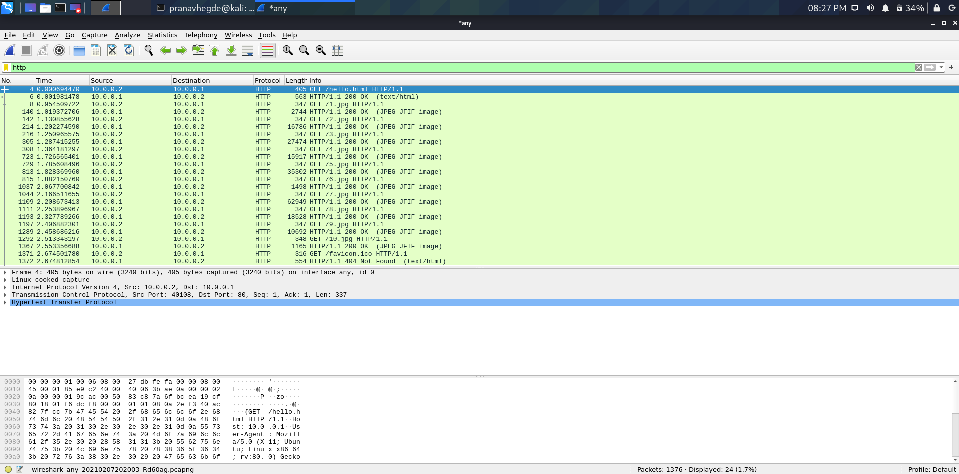

**PERSISTENT CONNECTION**

Persistent connection Wireshark http capture for different max connections:

1. Max persistent connections per server = 2

Time required to load all the 10 images: 2.657942877 - 0.935636378 = 1.722306499s

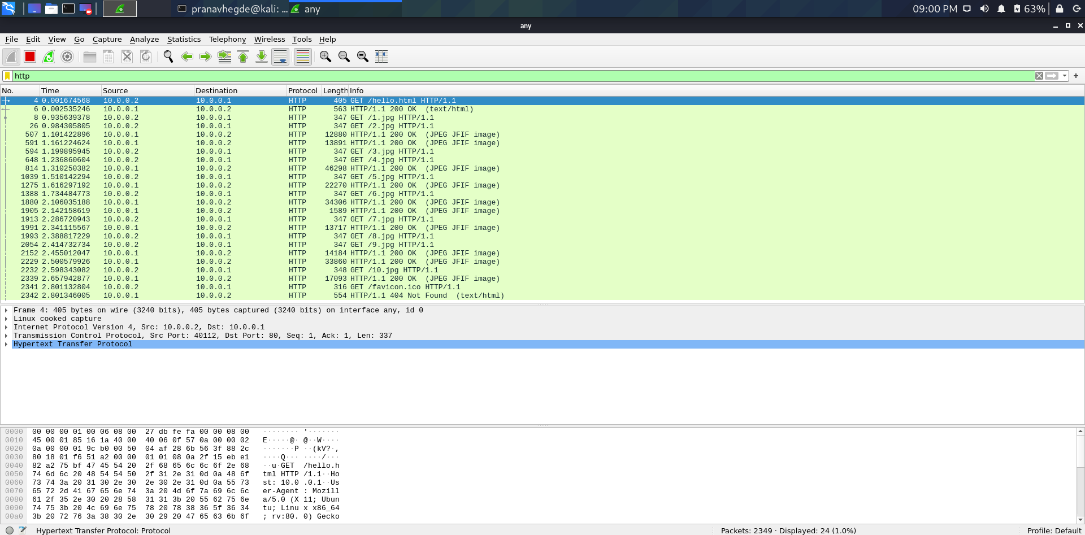

1. Max persistent connections per server = 4

Time required to load all the 10 images: 3.298980341 - 1.22942082 = 2.069559521s

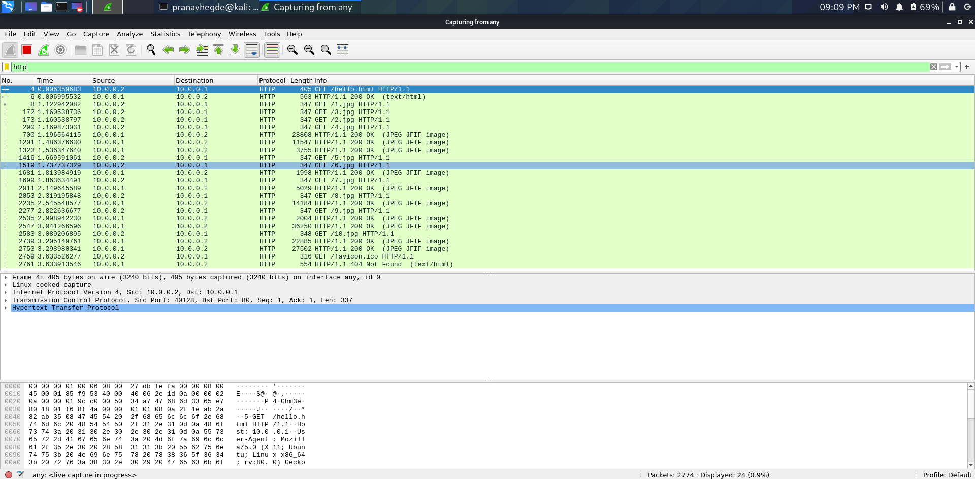

1. Max persistent connections per server = 6

Time required to load all the 10 images: 2.884312918 - 1.074173438 = 1.81013948s

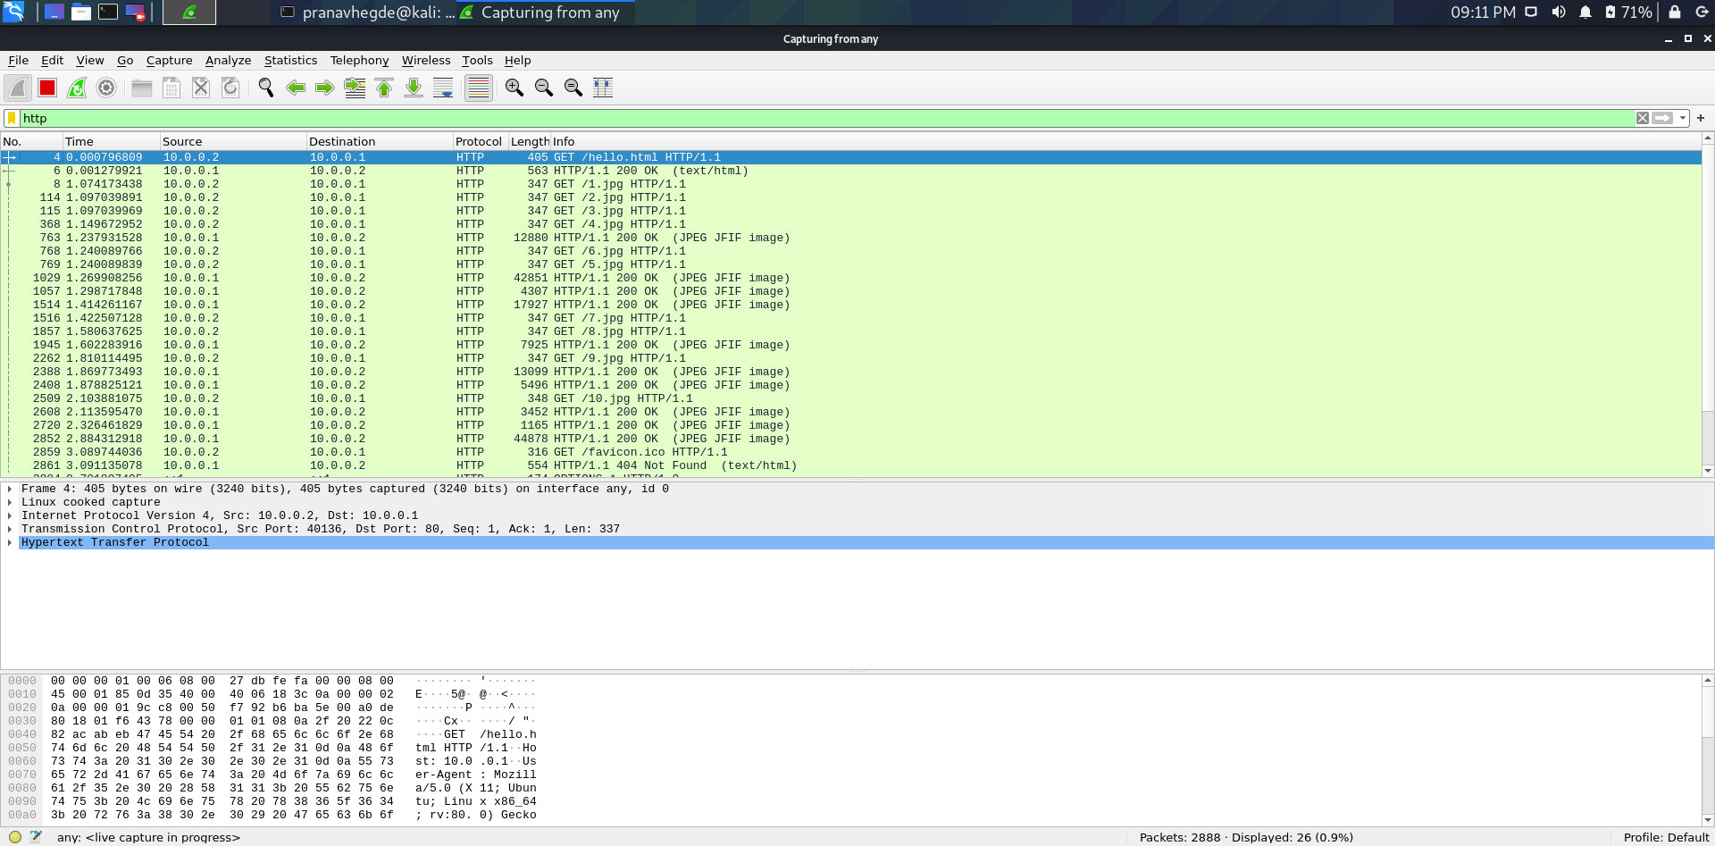

1. Max persistent connections per server = 8

Time required to load all the 10 images: 1.798985834 - 0.182257702 = 1.616728132s

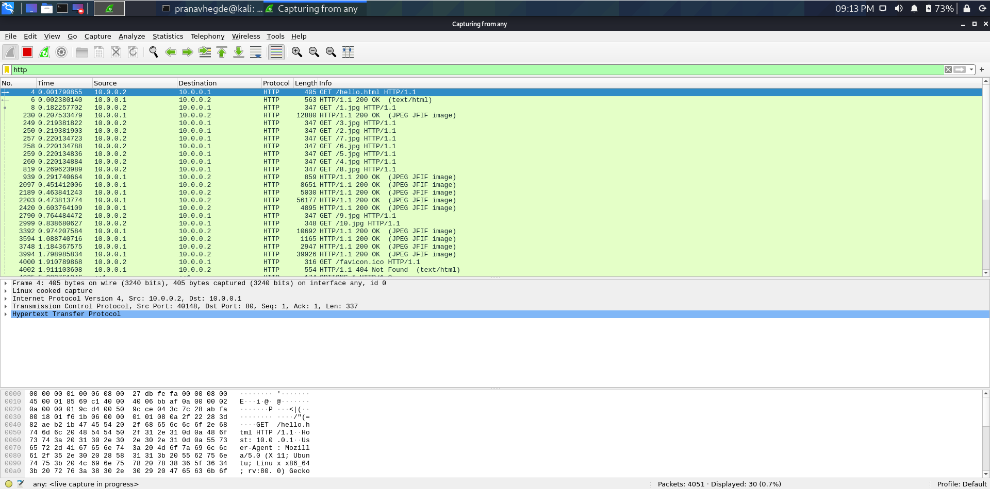

1. Max persistent connections per server = 10

Time required to load all the 10 images: 10.900631705 - 9.533910040 = 1.366721665s

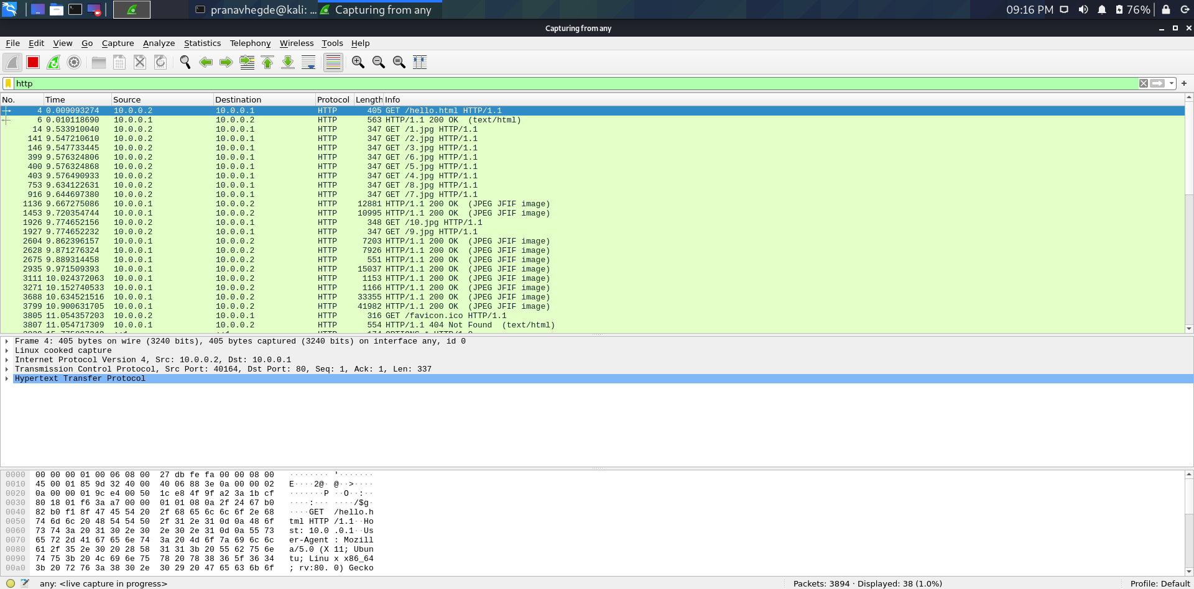

**OBSERVATION**

* An apache2 server was created in the server machine.
* 10 images all of whose size are above 2MB in size were used to create a webpage
* This webpage was then hosted via server machine on the apache2 server
* This webpage was then accessed via the client machine using the custom added IP address to the network interface.
* Some observations were made for a comparison between persistent and non-persistent http connections

**NON - PERSISTENT CONNECTION**

Time required for all the 10 images to load: 2.553356688 - 0.954509722 = 1.598846966s

**PERSISTENT CONNECTION**

1. Max persistent connections per server = 2

Time required to load all the 10 images: 2.657942877 - 0.935636378 = 1.722306499s

1. Max persistent connections per server = 4

Time required to load all the 10 images: 3.298980341 - 1.22942082 = 2.069559521s

1. Max persistent connections per server = 6

Time required to load all the 10 images: 2.884312918 - 1.074173438 = 1.81013948s

1. Max persistent connections per server = 8

Time required to load all the 10 images: 1.798985834 - 0.182257702 = 1.616728132s

1. Max persistent connections per server = 10

Time required to load all the 10 images: 10.900631705 - 9.533910040 = 1.366721665s

